Need for Cognition and Expectations as Determinants of Affective Experience – A replication
Life is like a box of chocolate – you never know what you are going to get. Forrest Gump leads us through the film named after him with his life philosophy, which sticks to him and his experiences throughout the film. While we will never know what will await us in the future, regardless of this we are often destined to form expectations of events, which have not yet taken place and lie in the recent or distant future. While these most of the time form spontaneously, we do have some control over what to expect from a certain happening. One can easily imagine a situation where big expectations could not be fulfilled and led to a feeling of disappointment, following an adjusting of expectations to avoid a repetition of said feeling. But is this really the best coping strategy? According to the Affective Expectation Model (AEM), this might not be the case. Here, expectations are defined as ‘‘people’s predictions about how they will feel in a particular situation or toward a specific stimulus’’. In their 1989 study Wilson et al., established said model “arguing that affect and emotion are often formed in an expectation-driven fashion” (Wilson et al., 1989). This induces, that our actual evaluation of an event is more dependent on our build expectations then on the quality of the event. It is predicted, that, when the affective expectation of a stimulus and its actual valence are incongruent and the incongruence goes unnoticed, this leads to an assimilation of the evaluation towards the expectation. Only when the discrepancy becomes salient, a contrast reaction happens and an evaluation contrary to the original expectation is formed. While Wilson et al. could not confirm the latter mentioned hypothesis in the original experiment, 10 years later Geers and Lassiter indeed found a way to create a contrast reaction to a primarily formed expectation by inducing a finer unitization of information regarding the stimulus and therefore enhancing the likeliness to detect an incongruence (Geers & Lassiter, 1999). Following studies conducted by the two examined to replicate said findings using optimism (Geers & Lassiter, 2002) and Need for Cognition (Geers & Lassiter, 2003) as a moderator. Further experiments have also shown a hedonic contrast to a primarily formed expectation when evaluating the taste of a specific food item, about which participants received varying information. When expecting to have a pleasant taste of an unpalatable food item, participants rated the stimulus as less positive in taste then other participants who had no expectation or a negative expectation of the stimulus (Zellner et al., 2004).
This paper discusses a replication attempt of study one of the experiment of Geers & Lassiter (2003) on the role of need for cognition and its influence on the relationship between affective expectation and affective experience. The concept of need for cognition is understood as “the tendency for an individual to engage in and enjoy thinking” (Cacioppo & Petty, 1982, p.116). Especially the tendency to “seek, acquire, think about, and reflect back on information to make sense of stimuli, relationships, and events in their world” (Cacioppo et al., 1996, p. 198) is what enhances the probability of a finer, more pronounced elaboration of information and therefore could influence ones capability to detect an incongruence of expectation-stimulus relation. Individuals with high in need for cognition evaluate messages more strongly in dependence of their quality (Cacioppo et al., 1983; Cacioppo et al., 1986), are more likely to have an information-oriented identity style (Berzonsky & Sullivan, 1992) and divide experiences into more meaningful actions and therefore memorize them better (Lassiter et al., 1991) than individuals low in need for cognition. Especially this tendency of persons with a high need for cognition to be “more likely to scrutinize their environment than individuals low in need for cognition” (Geers & Lassiter, 2003, p. 315) is mentioned as an argument for its supposed moderating effect.
The reason this experiment was chosen is at first the potential and relevance of the model itself. Handling others affective expectations is an important skill not only in marketing ones product, but also in managing people in a professional environment and leading them towards a certain direction. In both scenarios, it is important to know how an induced expectation can influence the evaluation of a selling object or a disclaimed goal and what are the consequences if this expectation is not fulfilled. Similar concepts of assimilation or contrast effects of the same stimulus, depending on the context have been used in the Inclusion/Exclusion model of mental construal processes (https://psycnet.apa.org/record/2007-01310-005). Furthermore, the affective expectation model is one of the more influential ones of recent psychological research with 339 google scholar citations, combining all articles published by Geers & Lassiter in the early 2000s.
We decided for this specific study to be replicated because, as far as we know, no direct replication was yet attempted. Furthermore need for cognition as a moderator for anchoring effects (/in similar paradigms) (Epley & Gilovich, 2006, Study 2a) has previously been involved in an unsuccessful replication attempt (see Röseler et al., 2022). Lastly, it is one of the earlier studies on the affective expectation model but nonetheless well documented, which makes it easier to replicate.

A Priori Sample Size Determination
In their original study, Geers and Lassiter found effect sizes of f = 0.2 for the relation of affective reactions to need for cognition in the positive expectation group and f = 0.27 for the negative expectation group a sample size of N = 160. Relative to the participants who had no expectations the affective reactions of the participants with a positive expectation became more positive as the need for cognition decreased and less positive as the need for cognition increased. By contrast, the participants who were induced with a negative expectation were less positive than those without an induced expectation, regardless of their manifestation in need for cognition.
To achieve 95% power for the smaller effect of f = 0.2, we would have needed 390 participants. We rounded this number to N = 400 (see https://osf.io/6ua4s for the preregistered power analysis code). Note that we did not achieve this sample size. Instead, only N = 252 participants took part in the study and could be used for the data analysis after applying exclusion criteria (see analysis plan). Achieved power was thus 81.37% for f = 0.2.
Analysis plan
To conduct a manipulation check, Data analysis was examined using R and the packages esc (for effect size calculation), psych (for reliability analysis and descriptives), ggplot2 (for plotting), dplyr (for na_if()) and effectsize for effect sizes. The entire analysis script was preregistered, and changes or additions are marked as “CHANGED” or “ADDED,” respectively (https://osf.io/2m3w6). The raw (https://osf.io/2s3tv) and processed (https://osf.io/4qwyt) datasets are available online.
At first, the dataset was cleansed by applying the exclusion criteria. Participants were excluded if they did not fulfill the necessary criteria to be considered for analysis, which was the completion of all of the following variables: need for cognition, affect index, experimental group. This lead to the exclusion of N = 1095 participants.
After a power analysis was conducted, the demographics of the final sample were analyzed, in detail age, gender and occupancy of the subjects. Subsequently, the internal consistency of the affect index and the Need for Cognition Scale was analyzed. A one-way ANOVA was run to examine the influence of the explanation film on the the expected liking of the film.
For the main analysis, an ANOVA was run to test the interaction effect of need for cognition and the expectation towards the film. In addition, the effect size of the single variables and their interaction was calculated. Furthermore, a plot similar to the one in the original paper (see Geers & Lassiter, 2003, p.318) was created to show the interaction effect of need for cognition with the affective reactions of the participants in dependence of their induced expectation.
Finally, a main effect between the participants’ expectations and the affect index was analyzed, as well as the remembered positivity of expectation and affect index.

Replication closeness evaluation
We reached out to Andrew Geers, one of the original authors, who helped us in reconstructing some of the materials, more precisely which parts of the films were used, how the materials were created and other details. In our attempt we tried to stay as close to the original study as possible. However, some changes had to be made. To point out the differences between our study and the original study and their reasoning’s, we created an overview based on the one used by Röseler et al. (Röseler et al., 2022) in their replication attempt of Epley and Gilovich (2006).

Table 1
Methodological differences between the original study and our replication study
Study feature | Geers & Lassiter, 2003, Study 1 |  |  | This study | Reason for change
Language of questionnaire | English |  |  | German | German participants
Type of sample | University undergraduates |  |  | Mixed sample, containing students, employed and unemployed subjects | Heterogeneous sample should increase NFC variance and thereby the effect size
Compensation | Partial course credit |  |  | Course credit and feedback | Facilitate participant recruitment
Type of instructions | Watching and evaluation of a video segment |  |  | Watching and evaluation of a video segment
Main variables that were collected | NFC, affective experience, affective expectation |  |  | NFC, affective experience, affective expectation
Further variables that were collected | Age, sex, viewing behavior |  |  | Age, sex, profession, viewing behavior, study program, substantive questions
Items used | Need for Cognition Scale by Cacioppo, Petty and Kao (1984); affective experience items adapted from Klaaren et al. (1994) |  |  | Need for Cognition Scale by Bless et al. (1994) | German participants
Exclusion criteria | Not reported |  |  | Participants must have completed all of the following variables: NFC, affect index, experimental group
Implementation format |  | In person, in the lab | Online survey

Results
Our sample consisted of N = 252 participants, which is more than 1.5 times the original study’s sample size. This sample size is sufficient to detect effects of f = 0.249 with 95% power. The achieved power for the original effect size of f = 0.200 was 81.37%.
Only 139 participants reported their age, with 113 missing cases. The reported mean age was M = 47.12 (SD = 16.42) with a range from 19 to 77. 77 male, 169 female and four diverse persons participated in the subject while 2 persons did not want to report their gender. 31 subjects reported, they were either bachelor- or master students, while only one person was in an apprenticeship. 153 subjects were employed with 5 in search for employment and 61 in retirement.
Data Quality Checks
Affective experience in the original experiment was measured via three items, which were adapted from the work by Klaaren et al. (1994) on the role of affective expectations on subjective experience and decision-making. Responses of those items were averaged to gain a single affect index, which reached an internal consistency of α = .93. To test, if this would also hold true for our questionnaire, we analyzed the internal consistency of our affect index items and found an α of .96 (95% CI [0.95, 0.97]).
To measure NFC in the original experiment, the 18-item version of the scale developed by Cacioppo, Petty and Kao (1984) was used. However, no internal consistency analysis was run, which we added in our analysis. Here we found a value of α = 0.85 (95% CI [0.83, 0.88]).
After testing for the internal consistency of our used items to capture the queried constructs, we examined a manipulation check, to test if the manipulation of the participants’ expectation was successful (same as in the original study). Therefore we ran a one-way ANOVA where a significant influence of induced expectation was found (df = 2, F = 3.90, p = .02). Subsequently, we conducted a Tukey’s test for multiple comparisons of the expectation groups’ means. Here, only a significant difference between the positive (M = 5.21, SD = 2.00) and the negative (M = 4.35, SD = 1.94) expectation group was found p = .02. A distribution of the data can be seen in figure 2. It should be noted that the interpretation of the pattern should be taken with caution, as people may succumb to hindsight bias when estimating their remembered emotions.

Figure 2
Distribution of remembered positivity of expectation by induced expectation (Remembered expectation by induced expectation)
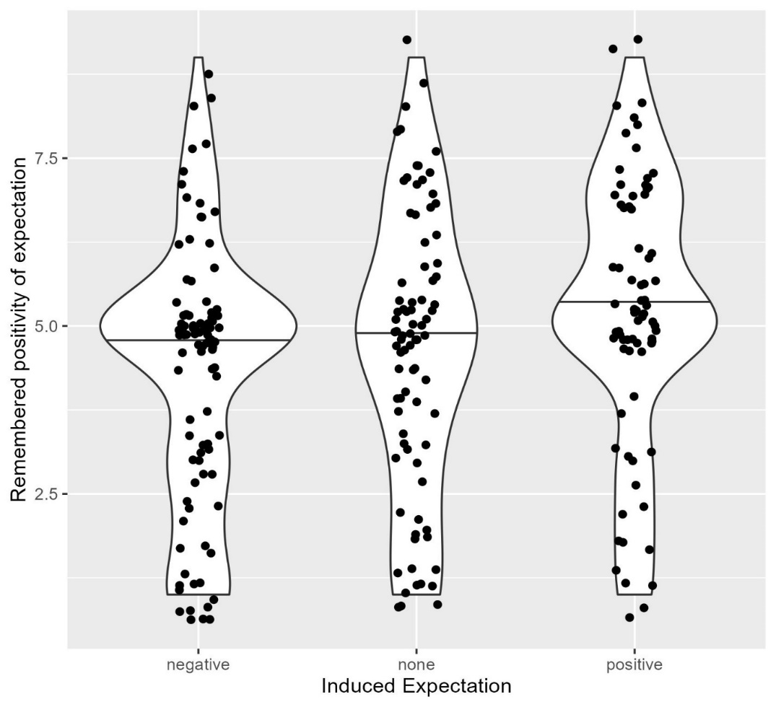
Note. Solid lines represent medians. Remembered positivity of expectations was measured on a 9 point scale (1 = not at all, 9 = very much).

Hypothesis Tests
A linear regression model was created using the assigned expectations, which were induced to the participants and their NFC value to test for interaction effects. For no variable or any interaction of the variables, a significant effect was found (ps ≥ .143) which could be seen in the characteristics of the model F(5, 246) = 1.86, p = .103, R² = 0.168. Furthermore, an ANOVA was run to test for general effects of NFC, expectation and their interaction. Again, no significant effect was found (ps ≥ .514).
Lastly, the effect sizes of the variables and their effect sizes were calculated. There was no main
effect of expectation condition on the affect index, F(2, 246) = 3.00, p = .051, η² = 0.02, 95% CI
[0, 0.07], need for cognition F(1, 246) = 1.43, p = .233, η² < 0.01, 95% CI [0, 0.04] or an interaction effect F(2, 246) = 0.92, p = .398, η² < 0.01, 95% CI [0, 0.04]. Subsequently, as in the original study (see Geers & Lassiter, 2003, p. 318), the slopes for the linear regression model for all expectation conditions were calculated. None of them was significantly different from zero:
Positive expectations: b = 0.288, se = 0.306, t(1, 73) = 0.94, p = .349
Negative expectations: b = 0.420, se = 0.275, t(1, 92) = 1.53, p = .130
Control group (no specific expectations): b = -0.131, se = 0.312, t(1, 81) = -0.420, p = .675.
Figure 2
Influence of Need for cognition on expectation by conditions
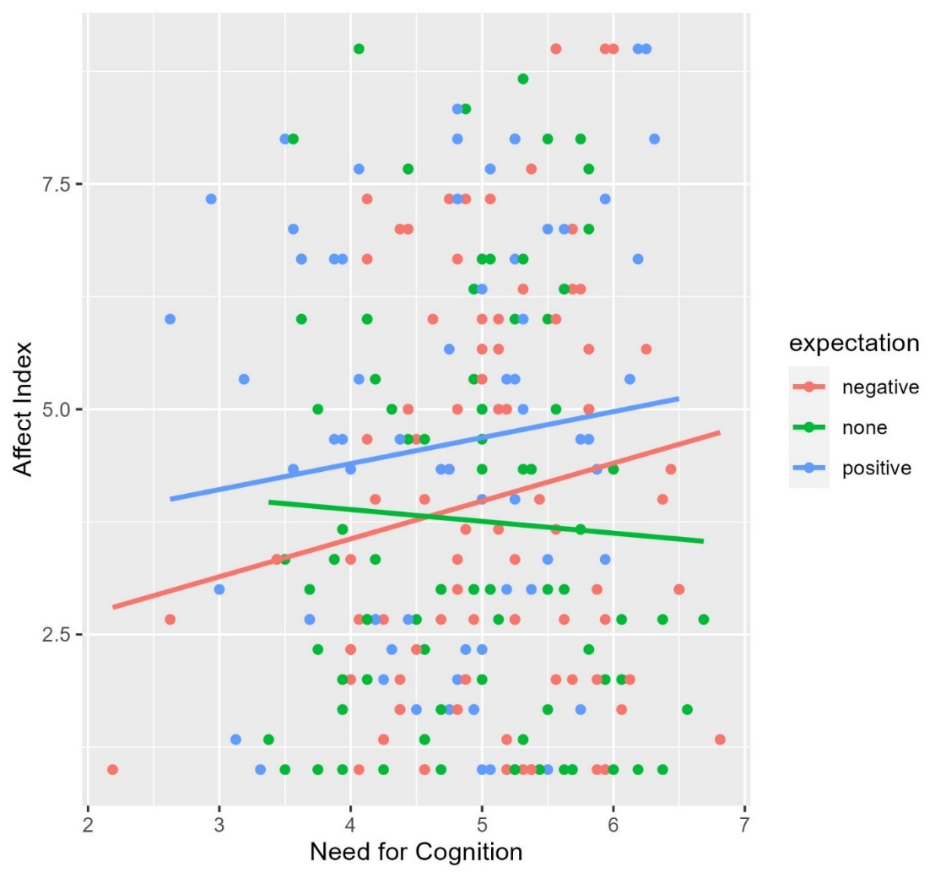
Note. Intercepts lie at I_{positive} = 3.2436, I_{negative} = 1.8808, I_{none} = 4.4105
Skalenpunkte und Extremas nennen

